PEER REVIEW DATA: PROJECT PRESENTATION - [MARQUIS ORCHARD] (2026).
Key Quotes:
- "Strong concept, relevant within social media today."
- "Love the quote 'Digital erasure of identity'."
- "Rich and interesting concept."

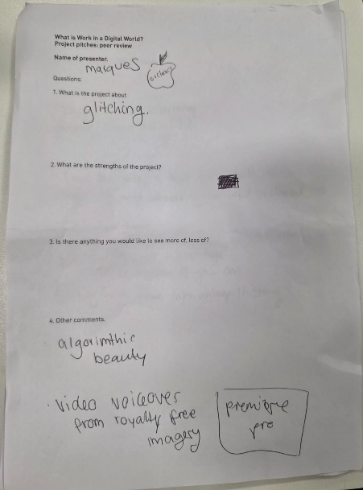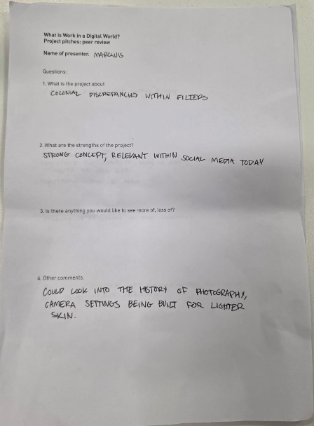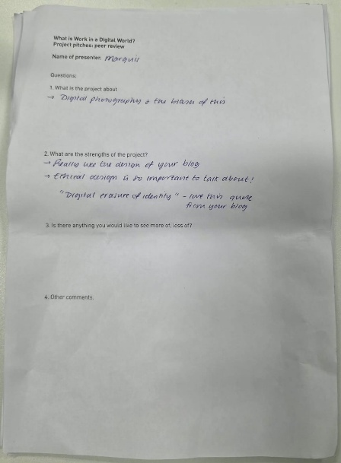
Reviewer 01 Reviewer 02 Reviewer 03

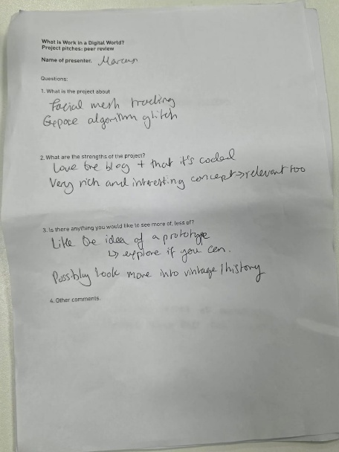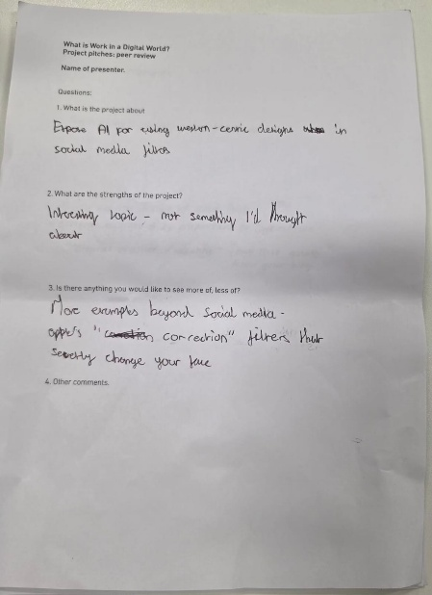
Reviewer 04 Reviewer 05 Reviewer 06

Following the peer review of my initial project pitch, I have implemented three key iterative changes to the final prototype and video script to deepen the research rigor:
- Historical Grounding: In response to feedback regarding the 'history of photography,' I integrated research into the 1950s Shirley Card the original 'Eurocentric' skin-tone calibration tool. This provides a direct historical ancestor to the modern 'Coded Inequity' (Benjamin, 2019) found in today's beauty filters.
- Hardware vs. Software: One reviewer noted that camera settings themselves are built for lighter skin. I have updated the Task 09 Technical Prototype to include 'Automated Skin Lightening' as a specific technical intervention zone, moving the project from a purely aesthetic critique to a technical one.
- Relatability & Scope: To make the concept more 'relatable' to a wider audience as suggested, I expanded the visual examples to include Apple’s 'Correction Filters'. This demonstrates that these algorithmic biases are not just found on social media, but are embedded in the default 'gaze' of our everyday devices.

